Lesson Name: Cook a Lizard

Age Range: K through 3rd

White Sands National Monument and “Cook a Lizard” lesson plan cooperating purpose statement: *The brilliant white dune field has resulted in extremely rapid and remarkable adaptations in endemic and native flora and fauna.* Certain species of insects and rodents have quickly evolved a more whitish coloration. Being able to blend into the surrounding sands is undoubtedly a large part of this evolutionary change, but there may be a part of this change that involves thermal energy and heat exchange.

National Science Standard: Make observations to provide evidence that energy can be transferred from place to place by sound, light, heat, and electric currents.

Theme: The absorption or reflection of light, as heat in lizards.

Goal/Objective: Understand that some surfaces absorb, and others reflect, heat energy from the Sun.

Preparation Time: 5 minutes if all materials are easily at hand.

Safety Considerations: No unusual safety considerations.

Materials Needed: Safety scissors (one per group), Cotton balls or Facial Tissues (one bag or one box), Two staplers (filled with staples ~ *verify prior to lesson*), Black and White construction paper, aluminum foil, assorted items that are conductor, insulator, reflective, absorbent, and about 30 “fun size” Tootsie Rolls or an equivalent, **sand from White Sands National Monument**, regular sand from a local source, and most importantly; this experiment needs a **sunny and warm day**. *Obviously lizards from the White Sands National Monument cannot be used, so the paper lizards will act as a substitute for that park resource.*

Lesson Time: 45 minutes to 1 hour. The amount of time will vary depending upon the amount of sunshine, the heat of the day, the size of the class and any extensions developed by the instructor.

Lesson Progression (suggested):

1. Students should place the white paper with the outline of a lizard, over one of the black sheets of paper.

2. Students then cut out the lizard diagram, and the result is a black and a white lizard.

3. Repeat step one (1), so that there are two black lizards, and two white lizards. *It should be obvious that the reason the white paper is on top, is because black lines will not appear on black paper*.

4. The “bodies” of the lizards fastened together with staples or tape, and are filled with the cotton ball “guts”, and the Tootsie Roll “meat”. The lizards are “fat” so the items can be put inside it, and the “lizard” can still be fastened together on the edges.

5. The lizards are taken outside to “roast” in the Sun.

i. Apt pupils may decide to shade the white lizard, or dribble water upon it.

ii. Equally, pupils may shine additional light upon the dark lizard by using mirrors, or the faces of i-phones or similar electronics as reflective devices.

6. Examine lizards, and examine Tootsie Rolls.

Probable Outcomes

1. The dark lizard will have Tootsie Roll “soup”.

2. The light lizard will have a tootsie roll that is still solid and edible.

Conclusions

1. Students will conclude that dark things get hot faster than white things.

Guided Discussion Suggestions

1. (Holding up the lizards) which lizard will you see in the shade of a yucca tree to stay cool? *There may be various answers, but we are leaning towards the black one, because the white one will stay cooler anyway.*

2. (Holding up the lizards) which lizard uses its color to stay warm? *There may be various answers, but we are leaning towards the black lizard.*

3. What color shirt are you going to wear on a sunny, hot day? *There may be various answers, but we are leaning towards the white shirt. This is even though a student’s favorite shirt is black☺.*

4. (Holding up jar of White Sand and a jar of regular sand) which sand will be hot on your feet? *There will be various answers, but we are leaning towards White Sand, because it is white. Saying “I will be safe and wear shoes” will still work at this age.* Sand can be mailed to teachers, if the teacher agrees to pay the postage.

Let us see what you know!!

Which shirt is hot in the summer!!

[](http://eastgrsports.com/?attachment_id=2780) [](javascript:edit(15284))

Which lizard is cooler in the summer Sun?

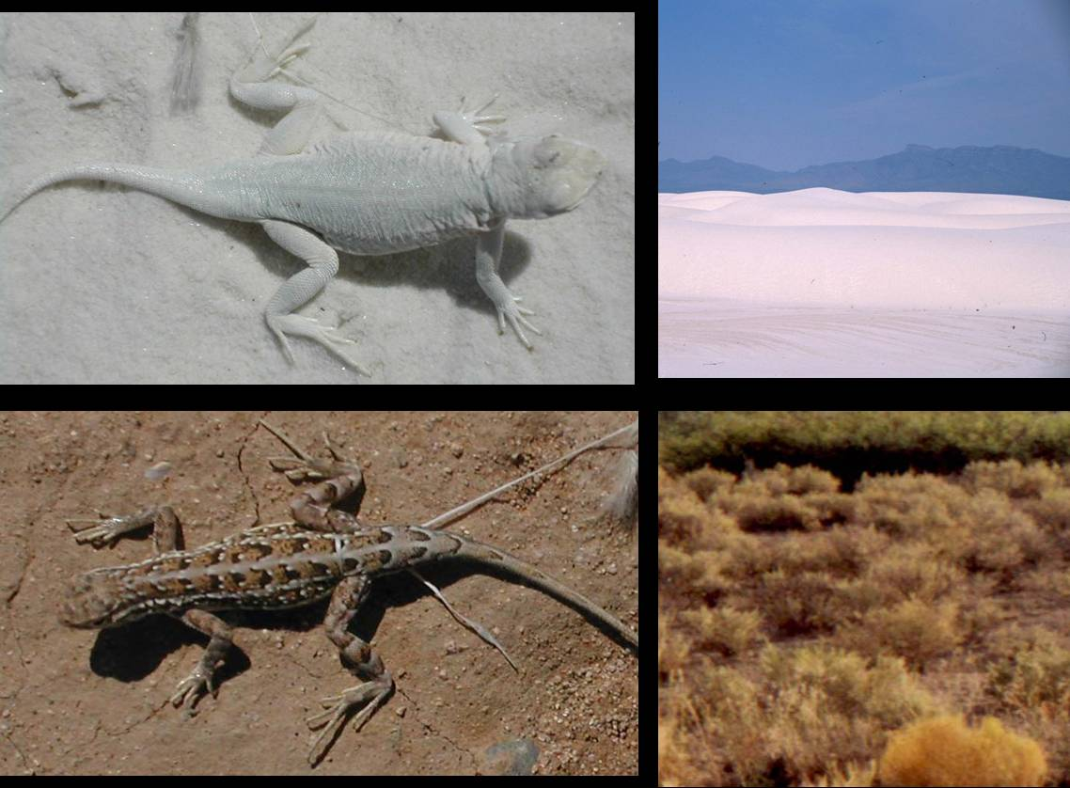 

Why should we **NEVER** leave a dog in a black car by itself?

It is lonely It is afraid It gets too cold It gets too hot

